# Lab 1 – Testing Kali Linux

|  |
| --- |
| * This is an individual assignment, and worth 20 points. * The due date and time is 1:00 (Sec 01) / 5:30 (Sec 76) on Thursday, September 5 * You need to provide your answers to the “Lab1-Outcome.docx.” Change the file name following the naming convention suggested below. * Naming convention is as follows: homework, hypen, last name, first initial, and extension (e.g., Lab1-Outcome-ImG.docx). If you do not follow the convention, I will deduct 1. * Make screenshots small so that you can save space. |

# Tasks

* (Task 1) Take screenshots of the outcome.

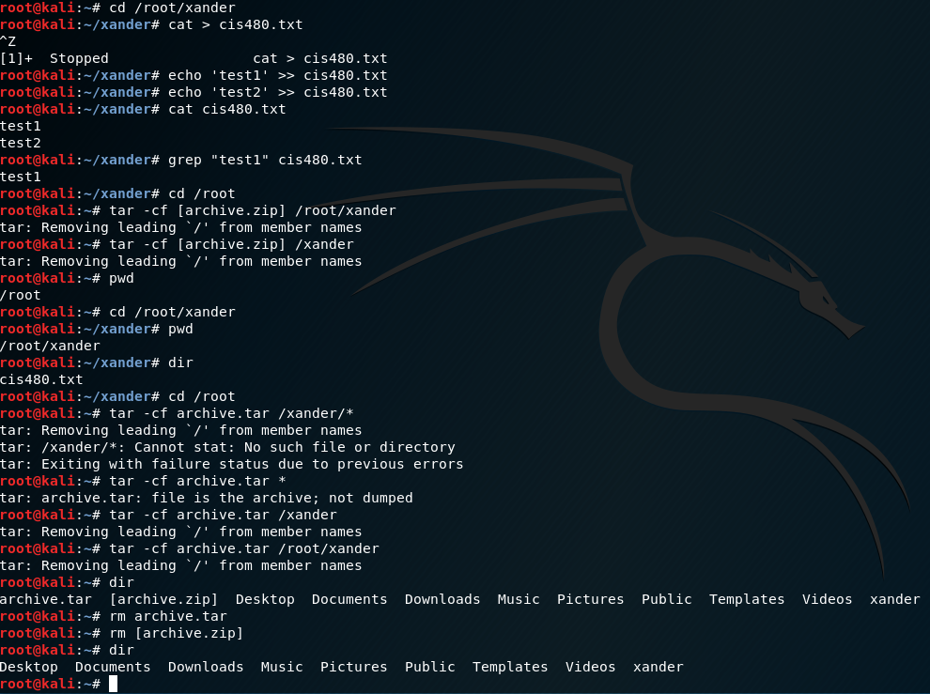

* (Task 2) Take a screenshot of the outcome.

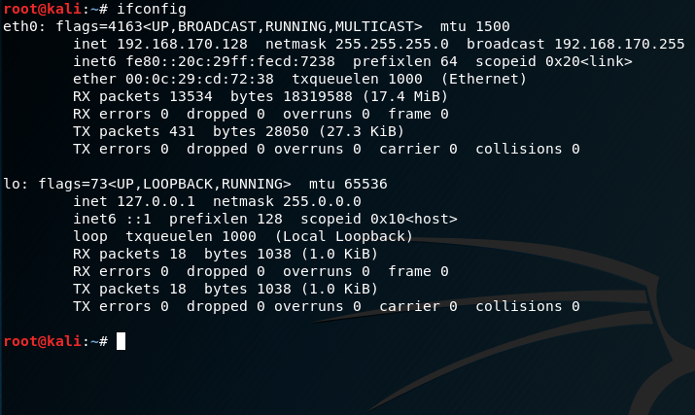

* (Task 3) Take a screenshot of the outcome.

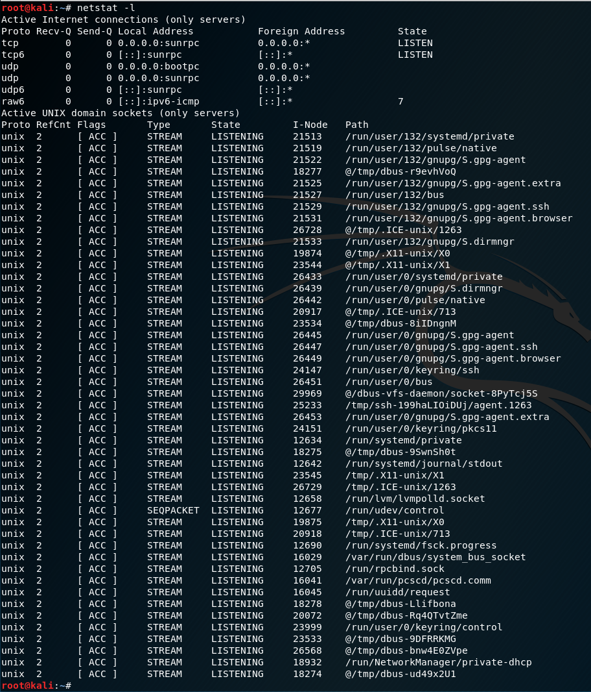

* (Task 4) Take a screenshot of the outcome.

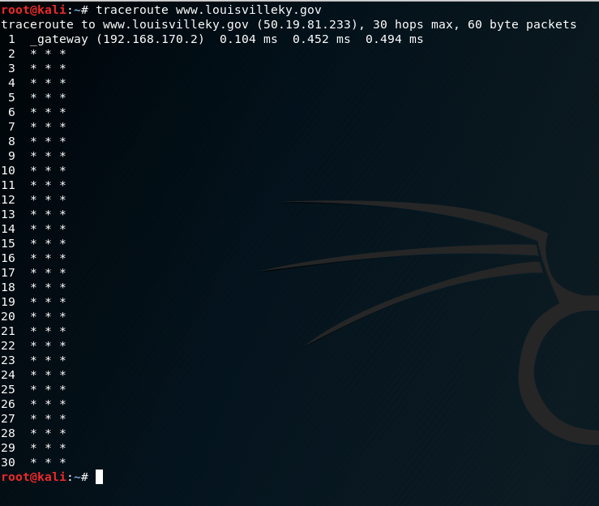

* (Task 5) Take a screenshot of the outcome.

